**OAKS OF RIGHTEOUSNESS S.1 END OF CHAPTER ACTIVITY OF INTEGRATION**

**HISTORY AND POLITICAL EDUCATION**

Context

Visitors from England wanted to visit the kingdoms in Uganda.They consulted with Balyejusa. Balyejusa told the visitors that there are many kingdoms in Uganda, but he was going to start by introducing them to the Buganda Kingdom and then Busoga Kingdom.The visitors were shocked. Mr.Balyejusa could not explain how different the kingdoms were.

Support Material

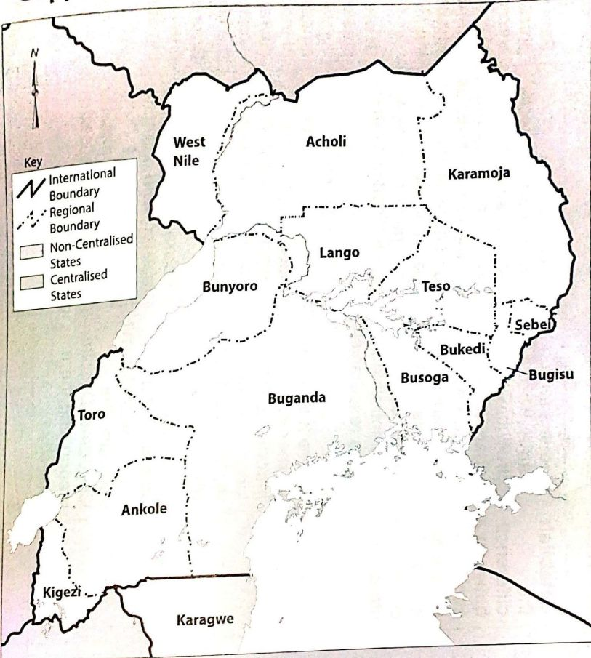Task

Prepare a written piece of information to help the visitors get the difference between the Buganda kingdom and the Busoga kingdom of Uganda.